LAB # 07
OPEN ENDED LAB
OBJECT:
The purpose of this ATM System Simulation is to showcase essential Java concurrency concepts by using a practical banking example. It incorporates inheritance, thread creation, synchronized methods, and inter-thread communication through wait() and notify() to safely manage shared resources as the Cashier loads money and the Customer withdraws it. The program also demonstrates how a deadlock can occur when two threads try to lock shared resources in an improper sequence, helping learners understand common concurrency issues and the significance of proper thread synchronization.
TASK:
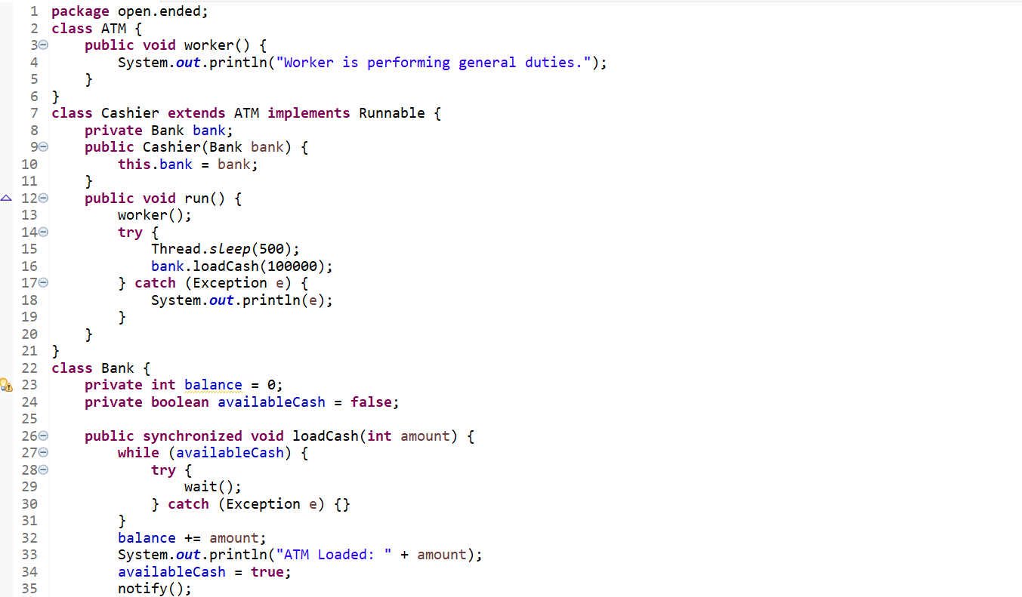
CODE:
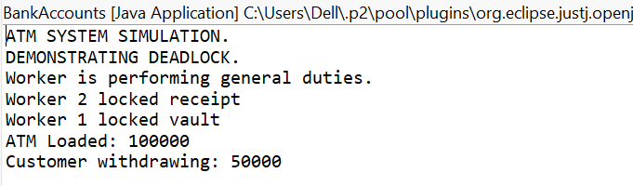
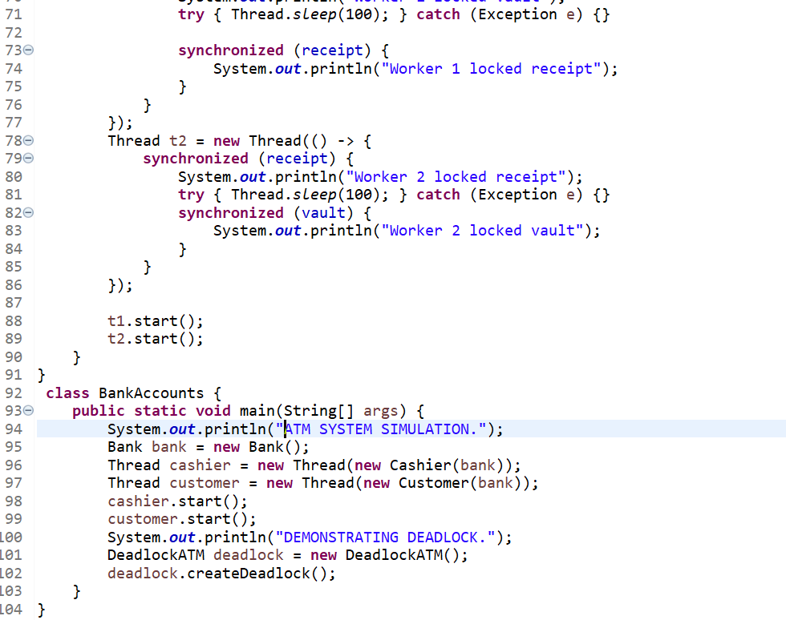
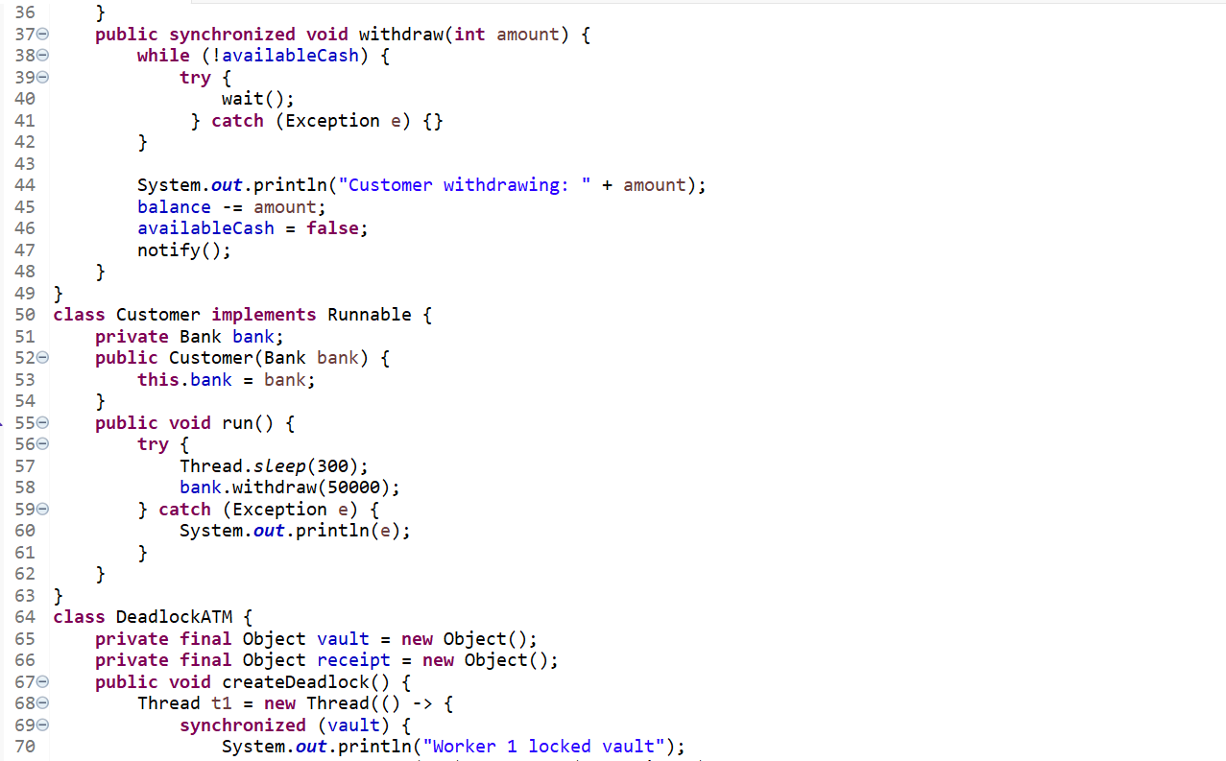
OUTPUT:

